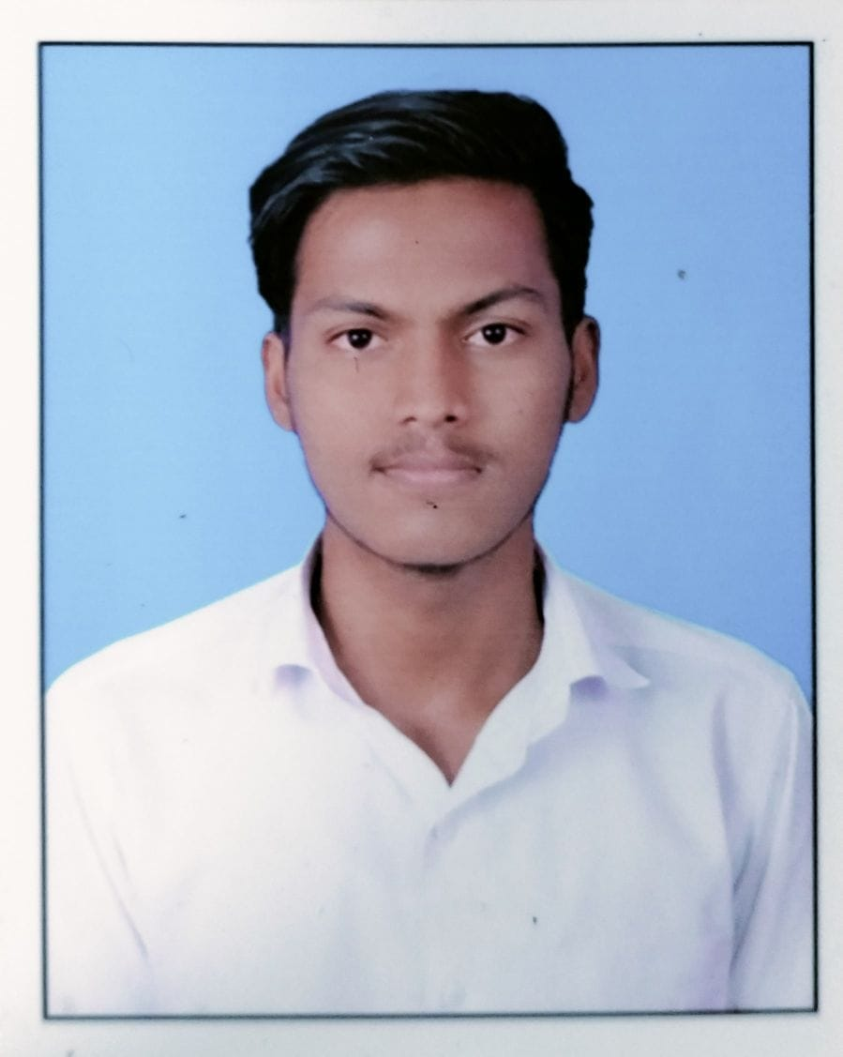
VENKATESH
Photo
Sai Teja gents Pg, AECS layout,
Kundalahalli Gate, Bengaluru, Karnataka-560037
Email ID: venk22ece@cmrit.ac.in
Mobile No: +91 8147032747
LinkedIn: https://www.linkedin.com/in/venkatesh-sindagi-871b51309
CAREER OBJECTIVE
To leverage my technical expertise and problem-solving skills in software development, contributing to innovative and scalable solutions. I aim to continuously learn and grow while adding value to the organization by delivering high-quality software systems that align with business goals and user needs.
EDUCATION QUALIFICATION
- Bachelor of Engineering – Electronics and Communication Engineering
CMRIT, AECS Layout, Bangalore
8.5, 2026(Pursuing)
- 12th – Science
Govt Ex-Mpl Pu collage, Ballari, Karnataka
85.5%,2021
- 10th
Christ the king school, Shorapur, Karnataka
90.88%,2020
TECHNICAL SKILLS
Languages: Python, C++, Verilog(Basics)
Frameworks: HTML, CSS, JavaScript, Django
Software: Matlab, Solidedge, Multisim, u-vision Keil
Database: MYSQL
PROJECTS
- Title: Diabetes prediction System
Description: Analyzes health data to assess an individual's risk of diabetes using machine learning algorithms. It supports early diagnosis and preventive care
Tech Stack: HTML, CSS, Python
Tool Use: VS Code, Jupyter notebook
- Title: Aurdino Alarm Clock Setting With Time Setting
Description: a system that automatically sets and triggers alarms based on real-time inputs, such as predefined schedules or sensor data. It utilizes Arduino UNO, a real-time clock module, and other components to provide an efficient and user-friendly alarm system.
Tech Stack: Microcontroller ,Real Time clock Module ,Input Device, Display, Power Supply, Sensors
Tool Used: Aurdino-Uno, Libraries, Tinkercad

CO-CURRICULAR & EXTRA CURRICULAR ACTIVITIES
- Online Courses & Certifications: Python zero to Hero, C++, Cybersecurity
- NSS: Social Connect And Responsibility

PERSONAL DETAILS
Date of Birth : 11/02/2004
Gender : Male
Nationality : Indian
Permanent Address : Rangampeth , Shorapur, Yadgir , Karnatka-586120
Linguistic Competency : Kannada, English, Hindi
Hobbies : Volleyball, Cricket, Kabaddi

